Year 7 Science
Curriculum and assessment plan
  - Aviation High

Level description | Context and cohort considerations (if applicable)
In Year 7 students explore the diversity of life on Earth and continue to develop their understanding of the role of classification in ordering and organising information. They use and develop models to represent and analyse the flow of energy and matter through ecosystems and explore the impact of changing components within these systems. They investigate relationships in the Earth-sun-moon system and use models to predict and explain events. They extend their understanding of the particulate nature of matter and explore how interactions of matter and energy at the sub-microscopic scale determine macroscopic properties.  They consider the effects of multiple forces when explaining changes in an object’s motion. Students make accurate measurements and analyse relationships between system components. They construct and use models to test hypotheses about phenomena at scales that are difficult to study directly and use these observations and other evidence to draw conclusions. They begin to understand the relationship between science and society and appreciate the need for ethical and cultural considerations when acquiring data.  Inquiry questions can help excite students’ curiosity and challenge their thinking. Following are examples of inquiry questions that could be used to prompt discussion and exploration:  - Mosquitoes are so annoying! What would the impact be if we got rid of them?  - What would Australian ecosystems look like without fire?  - How do simple machines make our lives easier?  - Why is being able to separate mixtures important?  - How have systems of classification changed over time? How do they differ across cultures? | Year 7 science is taught for 3x 70 minutes lessons per week.  The 1st week of Year 7 is junior secondary toolkit. During the 2nd week of the junior secondary toolkit, science teachers should be encouraged to utilise the labs to familiarise students with these.  Students at AHS have their own devices (iPads).  Adjustments are made to all assessment tasks for SWD’s.

Unit 1 — Think like a scientist: Physical Sciences | Unit 2 — Our small blue planet: Earth & Space Sciences | Unit 3 — Life under water: Biological Sciences | Unit 4 — Clean water for all: Chemical Sciences
Duration: Semester 1, Term 1, approximately 9 weeks | Duration: Semester 1, Term 2, approximately 9 weeks | Duration: Semester 1, Term 3, approximately 9 weeks | Duration: Semester 1, Term 4, approximately 9 weeks
This is an integrated aerospace/ science unit.  In the world of 24/7 access to information, it is increasingly important for students to think like scientists. Scientists are curious, ask questions and draw evidence-based conclusions using scientific knowledge and practices.  Year 7 students develop confidence in thinking like scientists as they learn about forces, lab safety and scientific inquiry practices. As students gain confidence in the lab, teachers provide feedback on safe practices and science inquiry skills through an examination.  While investigating balanced and unbalanced forces, students develop numeracy skills by using and rounding decimals and comparing the usefulness of different representations of the same data. They also use free body diagrams to communicate their understanding of the effects of forces on the movement of objects.  Investigating forces affords students opportunity to strengthen their critical and creative thinking capabilities through developing questions that can be investigated. Students provide evidence of this thinking through a second examination.  This unit provides a foundation for Unit 2 where students transfer their understanding of gravitational forces explaining the Earth-sun-moon system. | Watching the sun set and the moon rise leads students to develop a geocentric view of our place in the universe.  Viewed from space however, our small blue planet reveals its position as part of a much larger system.  The evidence used to move our geocentric belief to an evidence-based heliocentric understanding, challenges students to identify the factors that can lead to changes in scientific knowledge.  In researching this change in understanding, students apply reading comprehension strategies and practice critical and creative thinking as they identify and clarify significant information and opinion from a range of sources.  Students consider the development and use of models to explain concepts as they encounter ideas in science that are unable to be experienced firsthand. This includes where phenomena are very small, such as atoms, or where they are very large and long ago, such as the origin of the universe. Students explore the strengths and limitations of using models as representations. They develop a digital model to address misconceptions around the predictable phenomena of eclipses, tides, and seasons. | Seagrass beds provide food and habitat for marine organisms, improve water quality by reducing nutrient levels and reduce coastal erosion through stabilization of sediment. When flood waters carry silt across seagrass beds, catastrophic change can occur.  Environmental scientists use classification tools to measure the biodiversity of an ecosystem and monitor the biotic and abiotic factors. This understanding of healthy systems provides a standard against which damage from floodwater can be predicted and monitored, and the success of remediation processes measured.  In this unit, students continue to think like scientists and gain the skills in order to organise organisms and measure the health of seagrass beds. They investigate the impact of floodwaters and predict the effect of silt in this marine ecosystem.  There is a focus on sustainability, identification of potential ethical issues with the use of secondary data and recognition of the need for intercultural consideration when assessing field locations in this unit. This supports students to see themselves responding to contemporary science issues as they continue to think like scientists. | Building on the environmental focus of Unit 3, students apply their understanding of the particle model, to design a solution to mitigate the damage caused by floodwater carrying silt into marine ecosystems.  Students work in groups to identify a possible solution to the increasingly common environmental problem of floodwaters impacting marine ecosystems.  Through application of critical and creative thinking students develop investigable questions and in conducting their investigation they practise the safety and inquiry skills gained in Unit 1. They use data to support evidence-based conclusions on the effectiveness of their technique in removing silt from floodwater.  In evaluating their procedure and results, students identify unanswered questions, supporting them to understand the iterative nature of science inquiry. Understanding the role science plays in informing environmental policy invites student involvement in future citizen science projects.
 | Unit 1 |  | Unit 2 |  | Unit 3 |  |  | Unit 4
 | Assessment — Examination | Timing | Assessment — Investigation | Timing | Assessment — In class assignment | Timing |  | Assessment — Experimental investigation | Timing
Assessment | Integrated aerospace/ science unit.  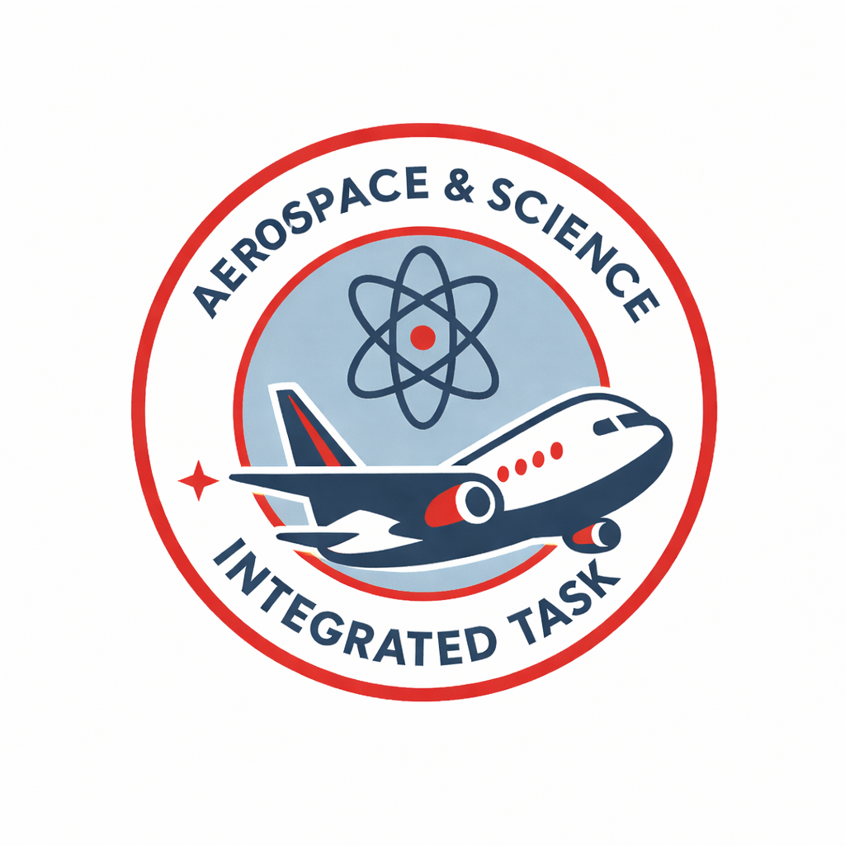  Students represent and explain the effects of balanced and unbalanced forces.  Examination  40 minutes  Written response, under supervised conditions  Feedback to students: quizzes, diagnostic tests, formative assessment  AI Statement: In this exam, students may not use AI for any aspect of the task | Week 4-5 | Students develop a digital model to explain their understanding of the cycles of the Earth-sun-moon system. They identify factors that over time changed our understanding of the effects of these cycles on Earth phenomena.  Investigation  Multi-modal digital model  Written response (400-600 words)  Feedback to students: teacher conferencing and/ or whole class feedback  AI Statement: In this assignment, AI may be used to generate aspects of the task:  - Students may use Writer’s Toolbox (WTB) to draft written components and use WTB to obtain feedback on their writing. | Week 9 | Students classify insects using a dichotomous key. They construct a branched dichotomous key to classify an unknown species and then evaluate the effectiveness of a provided dichotomous key.  Assignment (in-class)  Written response, under supervised conditions  Feedback to students: formative assessment  AI Statement: In this exam, students may not use AI for any aspect of the task |  | Week 4-5 | Students plan and conduct an experiment to investigate techniques to remove silt from flood water.  Experimental investigation  Group work  Individual response  Written response (400-600 words)  Feedback to students: individual Values of Inquiry (VOI) written feedback  AI Statement: In this assignment, AI may be used to generate aspects of the task:  - Students may use Writer’s Toolbox (WTB) to draft written components and use WTB to obtain feedback on their writing. | Week 9
Assessment | Assessment — Examination | Week 9 |  | Week 9 | Assessment - Investigation |  | Week 9 |  | Week 9
Assessment | Integrated aerospace/ science unit.  Students demonstrate their understanding of safe laboratory protocols and science inquiry.  Examination  30 minutes  Written response, under supervised conditions  Feedback to students: quizzes, diagnostic tests, formative assessment  AI Statement: In this exam, students may not use AI for any aspect of the task | Week 9 |  | Week 9 | Students research the impact of flood waters on seagrass beds and predict the effect of silt on the ecosystem.  Investigation  Written response (400-600 words)  Feedback to students: individual checklist  AI Statement: In this assignment, AI may be used to generate aspects of the task:  - Students may use Writer’s Toolbox (WTB) to draft written components and use WTB to obtain feedback on their writing. |  | Week 9 |  | Week 9
Achievement standard | By the end of Year 7 students explain how biological diversity is ordered and organised. They represent flows of matter and energy in ecosystems and predict the effects of environmental changes. They model cycles in the Earth-sun-moon system and explain the effects of these cycles on Earth phenomena. They represent and explain the effects of forces acting on objects. They use particle theory to explain the physical properties of substances and develop processes that separate mixtures. Students identify the factors that can influence development of and lead to changes in scientific knowledge. They explain how scientific responses are developed and can impact society. They explain the role of science communication in shaping viewpoints, policies, and regulations.  Students plan and conduct safe, reproducible investigations to test relationships and aspects of scientific models. They identify potential ethical issues and intercultural considerations required for field locations or use of secondary data. They use equipment to generate and record data with precision. They select and construct appropriate representations to organise data and information. They process data and information and analyse it to describe patterns, trends, and relationships. They identify possible sources of error in methods and identify unanswered questions in conclusions and claims. They identify evidence to support their conclusions and construct arguments to support or dispute claims. They select and use language and text features appropriately for their purpose and audience when communicating their ideas and findings. |  | By the end of Year 7 students explain how biological diversity is ordered and organised. They represent flows of matter and energy in ecosystems and predict the effects of environmental changes. They model cycles in the Earth-sun-moon system and explain the effects of these cycles on Earth phenomena. They represent and explain the effects of forces acting on objects. They use particle theory to explain the physical properties of substances and develop processes that separate mixtures. Students identify the factors that can influence development of and lead to changes in scientific knowledge. They explain how scientific responses are developed and can impact society. They explain the role of science communication in shaping viewpoints, policies, and regulations.  Students plan and conduct safe, reproducible investigations to test relationships and aspects of scientific models. They identify potential ethical issues and intercultural considerations required for field locations or use of secondary data. They use equipment to generate and record data with precision. They select and construct appropriate representations to organise data and information. They process data and information and analyse it to describe patterns, trends, and relationships. They identify possible sources of error in methods and identify unanswered questions in conclusions and claims. They identify evidence to support their conclusions and construct arguments to support or dispute claims. They select and use language and text features appropriately for their purpose and audience when communicating their ideas and findings. |  | By the end of Year 7 students explain how biological diversity is ordered and organised. They represent flows of matter and energy in ecosystems and predict the effects of environmental changes. They model cycles in the Earth-sun-moon system and explain the effects of these cycles on Earth phenomena. They represent and explain the effects of forces acting on objects. They use particle theory to explain the physical properties of substances and develop processes that separate mixtures. Students identify the factors that can influence development of and lead to changes in scientific knowledge. They explain how scientific responses are developed and can impact society. They explain the role of science communication in shaping viewpoints, policies, and regulations.  Students plan and conduct safe, reproducible investigations to test relationships and aspects of scientific models. They identify potential ethical issues and intercultural considerations required for field locations or use of secondary data. They use equipment to generate and record data with precision. They select and construct appropriate representations to organise data and information. They process data and information and analyse it to describe patterns, trends, and relationships. They identify possible sources of error in methods and identify unanswered questions in conclusions and claims. They identify evidence to support their conclusions and construct arguments to support or dispute claims. They select and use language and text features appropriately for their purpose and audience when communicating their ideas and findings. |  |  | By the end of Year 7 students explain how biological diversity is ordered and organised. They represent flows of matter and energy in ecosystems and predict the effects of environmental changes. They model cycles in the Earth-sun-moon system and explain the effects of these cycles on Earth phenomena. They represent and explain the effects of forces acting on objects. They use particle theory to explain the physical properties of substances and develop processes that separate mixtures. Students identify the factors that can influence development of and lead to changes in scientific knowledge. They explain how scientific responses are developed and can impact society. They explain the role of science communication in shaping viewpoints, policies, and regulations.  Students plan and conduct safe, reproducible investigations to test relationships and aspects of scientific models. They identify potential ethical issues and intercultural considerations required for field locations or use of secondary data. They use equipment to generate and record data with precision. They select and construct appropriate representations to organise data and information. They process data and information and analyse it to describe patterns, trends, and relationships. They identify possible sources of error in methods and identify unanswered questions in conclusions and claims. They identify evidence to support their conclusions and construct arguments to support or dispute claims. They select and use language and text features appropriately for their purpose and audience when communicating their ideas and findings.
Moderation | Year 7 science coordinator to email tasks to team at the end of Term 4 of previous year. This should include proposed adjusted assessment. Feedback on task/s to be given to coordinator by the end of week 1. Calibration meeting to be held by the end of Week 2. Meeting to be led by Year 7 science coordinator. No major adjustments to occur to task during calibration meeting. Diagnostic tests (formative assessment) should be run with students prior to examination to allow students to be given feedback on their progress. After the examination, the HOD facilitates professional conversations to confirm grade boundaries. This may include a focus group with Year 7 students on the difficulty of the task/s. Exams may be utilised for whole school moderation in week 10. |  | Year 7 science coordinator to email tasks to team at the end of Term 1. This should include proposed adjusted assessment. Feedback on task/s to be given to coordinator by the end of week 1. Calibration meeting to be held by the end of Week 2. Meeting to be led by Year 7 science coordinator. No major adjustments to occur to task during calibration meeting. Draft moderation to be facilitated by coordinator in about week 7/8. Feedback from draft moderation to be provided to students. After the assessment task is submitted, the HOD facilitates professional conversations to confirm grade boundaries. This may include a focus group with Year 7 students on the difficulty of the task/s. Assignments may be utilised for whole school moderation in week 10. |  | Year 7 science coordinator to email tasks to team at the end of Term 2. This should include proposed adjusted assessment. Feedback on task/s to be given to coordinator by the end of week 1. Calibration meeting to be held by the end of Week 2. Meeting to be led by Year 7 science coordinator. No major adjustments to occur to task during calibration meeting. Draft moderation to be facilitated by coordinator in about week 7/8. Feedback from draft moderation to be provided to students. After the assessment task is submitted, the HOD facilitates professional conversations to confirm grade boundaries. This may include a focus group with Year 7 students on the difficulty of the task/s. Assignments may be utilised for whole school moderation in week 10. |  |  | Year 7 science coordinator to email tasks to team at the end of Term 3. This should include proposed adjusted assessment. Feedback on task/s to be given to coordinator by the end of week 1. Calibration meeting to be held by the end of Week 2. Meeting to be led by Year 7 science coordinator. No major adjustments to occur to task during calibration meeting. Draft moderation to be facilitated by coordinator in about week 7/8. Feedback from draft moderation to be provided to students. After the assessment task is submitted, the HOD facilitates professional conversations to confirm grade boundaries. This may include a focus group with Year 7 students on the difficulty of the task/s. Assignments may be utilised for whole school moderation in week 10.

Content descriptions | Units |  |  |  | Content descriptions | Units |  |  |  | Content descriptions | Units
Science understanding | 1 | 2 | 3 | 4 | Science as a human endeavour | 1 | 2 | 3 | 4 | Science inquiry | 1 | 2 | 3 | 4
Biological sciences  investigate the role of classification in ordering and organising the diversity of life on Earth and use and develop classification tools including dichotomous keys AC9S7U01 | £ | £ | R | £ | Nature and development of science  explain how new evidence or different perspectives can lead to changes in scientific knowledge AC9S7H01 | £ | R | £ | £ | Questioning and predicting  develop investigable questions, reasoned predictions, and hypotheses to explore scientific models, identify patterns and test relationships AC9S7I01 | R | R | £ | R
use models, including food webs, to represent matter and energy flow in ecosystems and predict the impact of changing abiotic and biotic factors on populations AC9S7U02 | £ | £ | R | £ | investigate how cultural perspectives and world views influence the development of scientific knowledge AC9S7H02 | £ | R | £ | £ | Planning and conducting  plan and conduct reproducible investigations to answer questions and test hypotheses, including identifying variables and assumptions and, as appropriate, recognising and managing risks, considering ethical issues, and recognising key considerations regarding heritage sites and artefacts on Country/Place AC9S7I02 | R | £ | R | R
Earth and space sciences  model cyclic changes in the relative positions of the Earth, sun and moon and explain how these cycles cause eclipses and influence predictable phenomena on Earth, including seasons and tides AC9S7U03 | £ | R | £ | £ | Use and influence of science  examine how proposed scientific responses to contemporary issues may impact on society and explore ethical, environmental, social, and economic considerations AC9S7H03 | £ | R | £ | £ | select and use equipment to generate and record data with precision, using digital tools as appropriate AC9S7I03 | £ | £ | £ | R
Physical sciences  investigate and represent balanced and unbalanced forces, including gravitational force, acting on objects, and relate changes in an object’s motion to its mass and the magnitude and direction of forces acting on it AC9S7U04 | R | £ | £ | £ | explore the role of science communication in informing individual viewpoints and community policies and regulations AC9S7H04 | £ | £ | R | £ | Processing, modelling and analysing  select and construct appropriate representations, including tables, graphs, models, and mathematical relationships, to organise and process data and information AC9S7I04 | R | R | £ | R
Chemical sciences  use particle theory to describe the arrangement of particles in a substance, including the motion of and attraction between particles, and relate this to the properties of the substance AC9S7U05 | £ | £ | £ | R |  |  |  |  |  | analyse data and information to describe patterns, trends and relationships and identify anomalies AC9S7I05 | R | £ | R | £
use a particle model to describe differences between pure substances and mixtures and apply understanding of properties of substances to separate mixtures AC9S7U06 | £ | £ | £ | R |  |  |  |  |  | Evaluating  analyse methods, conclusions and claims for assumptions, possible sources of error, conflicting evidence, and unanswered questions AC9S7I06 | R | £ | R | £
 |  |  |  |  |  |  |  |  |  | construct evidence-based arguments to support conclusions or evaluate claims and consider any ethical issues and cultural protocols associated with using or citing secondary data or information AC9S7I07 | R | £ | R | R
 |  |  |  |  |  |  |  |  |  | Communicating  write and create texts to communicate ideas, findings and arguments for specific purposes and audiences, including selection of appropriate language and text features, using digital tools as appropriate AC9S7I08 | £ | R | £ | R
Note: Adjust the table to reflect the number of units you will offer. Check or uncheck the columns as appropriate for each unit.
General capabilities | Units |  |  |  |  | Cross-curriculum priorities | Units
 | 1 | 2 | 3 | 4 |  |  | 1 | 2 | 3 | 4
Critical and creative thinking | R | R | £ | R |  | Aboriginal and Torres Strait Islander histories and cultures | £ | R | R | £
Digital literacy | £ | R | £ | £ |  | Asia and Australia’s engagement with Asia | £ | £ | £ | £
Ethical understanding | £ | £ | R | £ |  | Sustainability | £ | £ | R | £
Intercultural understanding | £ | R | £ | £
Literacy | R | R | R | R
Numeracy | R | £ | £ | R
Personal and social capability | R | R | R | R
 © State of Queensland (QCAA) 2023
Licence: https://creativecommons.org/licenses/by/4.0 | Copyright notice: www.qcaa.qld.edu.au/copyright — lists the full terms and conditions, which specify certain exceptions to the licence. | Attribution (include the link): © State of Queensland (QCAA) 2023 www.qcaa.qld.edu.au/copyright.
Unless otherwise indicated material from the Australian Curriculum is © ACARA 2010–present, licensed under CC BY 4.0. For the latest information and additional terms of use, please check the Australian Curriculum website and its copyright notice.

