Year 8 Science
Curriculum and assessment plan
  - Aviation High

Level description | Context and cohort considerations (if applicable)
In Year 8 students are introduced to cells as microscopic structures that explain macroscopic features of living systems. They connect form and function at an organ level and explore the organisation of a body system in terms of flows of matter between interdependent organs. They continue to develop a view of Earth as a dynamic system, in which change occurs across a range of timescales. They classify different types of energy and describe the role of energy in causing change in systems, including the role of energy and forces in the geosphere.  They learn to classify matter at the atomic level and distinguish between chemical and physical change. They understand that chemical reactions also involve energy. Students use experimentation to isolate relationships between components in systems and explain these relationships through increasingly complex representations. They consider the magnitude of properties and events and use appropriate units to describe proportional relationships.  Inquiry questions can help excite students’ curiosity and challenge their thinking. Following are examples of inquiry questions that could be used to prompt discussion and exploration:  - Can we predict changes to the shape and position of continents?  - Are facts enough? How much does science communication matter?  - How can we tell if a substance has changed?  - How can we best measure what we cannot directly see?  - How is a leaf like a lung? | Year 8 science is taught for 3x 70-minute lessons per week.  Students at AHS have their own devices (in Year 8, iPads)  Adjustments are made to all assessment tasks for SWD’s.

Unit 1 —Physical Sciences | Unit 2 — Biological Sciences | Unit 3 — Earth & Space Sciences | Unit 4 — C
Duration: Semester 1, Term 1, Approximately 9 weeks | Duration: Semester 1, Term 2, Approximately 9 weeks | Duration: Semester 2, Term 3, Approximately 9 weeks | Duration: Semester 2, Term 4, Approximately 9 weeks
This is an integrated aerospace/ science unit.  Building on learnings from Year 7, Year 8 students learn about forces, specifically how energy is transferred and transformed in simple systems. Students work in groups to design, build and test rubber-band powered aeroplanes, and collect and collate data (distance vs time). They identify energy transfers and transformations and evaluate the data their group has collected. | Students learn about cell theory and the development of the microscope. They compare plant and animal cells. Students research and explain why plant cells have chloroplasts. Students subsequently learn about organs and organ systems, focussing on the digestive, respiratory, circulatory and skeletal systems. They choose an animal to research and then compare the differences between animal and human systems. | Students learn about big Earth processes. They begin by looking at the structure of the Earth and then learn about plate tectonic theory, focussing on the three main fault movements (divergent, transform, convergent). Students learn about the development of plate tectonic theory, beginning with Alfred Wegener’s observation in the early nineteenth century. Following on from plate tectonic theory, students learn about the cycle. They begin by looking at the properties of minerals and then look at each type in detail (metamorphic, igneous, sedimentary). Then students look at how the properties of rocks are useful in society. They also look at ethical considerations in mining. | Students learn about the Particle Model. They identify solids, liquids and gases and explain how the arrangement of particles effects their state. Students describe and represent the difference between atoms and molecules. They use their newfound conceptual knowledge to design an experiment that demonstrates the Particle Model. They identify assumptions and unanswered questions. Students work in groups to research the development of the periodic table. They research the impact the periodic table had on society and the impact the development of technology had on the creation of the periodic table. They reflect on how the PT was communicated and use this to reflect on the significance of science communication. In groups, they create a slideshow with a performance element and present their findings to the class.

 | Unit 1 |  | Unit 2 |  | Unit 3 |  | Unit 4
 | Assessment — Investigation | Timing | Assessment — Investigation | Timing | Assessment — Examination | Timing | Assessment — Investigation | Timing
Assessment | Integrated aerospace/ science unit.  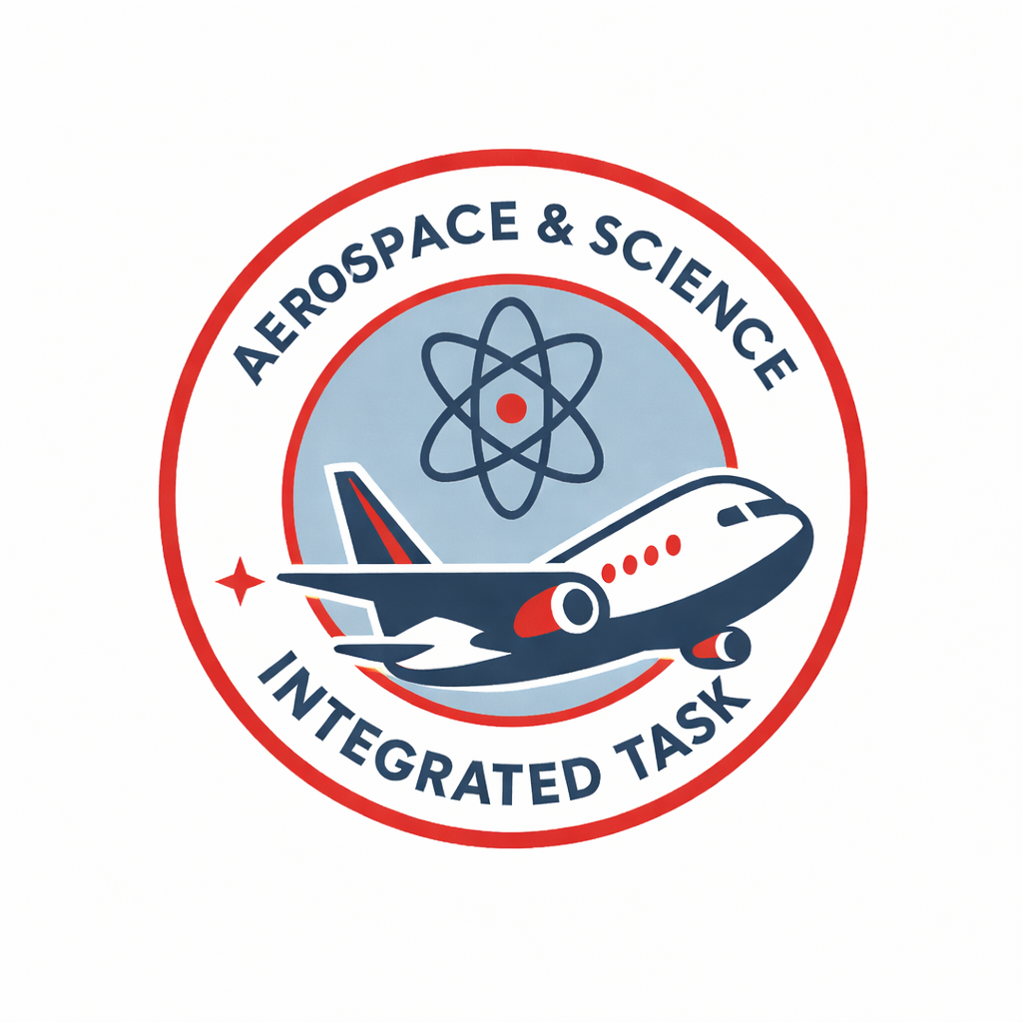  Students design, build and modify rubber band powered cars and use these to collect data. They relate collected data to the transferral and transformation of energy in simple systems (i.e., their rubber band powered cars).  Experimental investigation  Group work  Individual response  Written response (500-600 words)  Feedback to students: individual Values of Inquiry (VOI) written feedback  AI Statement: In this assignment, AI may be used to generate aspects of the task:  Students:  - may use WTB to draft written components and obtain feedback on their writing  - may use Corella (EQ generative AI platform) to obtain feedback on aspects of their assignment  - may use Corella to construct the method and equipment list | Due: Week 9 | After studying cell structure, students explain why plant cells require chloroplasts.  Research investigation (cell theory)  Individual response  Written response (100-120 words)  Feedback to students: written feedback on WTB  AI Statement: In this assignment, AI may be used to generate aspects of the task:  Students:  - may use Writer’s Toolbox (WTB) to draft written components and use WTB to obtain feedback on their writing. | Due Week 2-3 | Students learn about big Earth processes and plate tectonic theory, including scientists who developed the theory.  Examination (Plate tectonics)  1x 60 minutes  Written response, under supervised conditions  Feedback to students: quizzes, diagnostic tests, formative assessment  AI Statement: In this exam, students may not use AI for any aspect of the task | Due week  5-6 | Students design their own experiment to determine how heat effects substances when mixed. They identify physical and chemical change and explain what happens to the particles (atoms/ molecules) during their experiment.  Experimental Investigation  Group work  Individual response  Written response (500-600 words)  Feedback to students: whole class feedback  AI Statement: In this assignment, AI may be used to generate aspects of the task:  Students:  - may use Writer’s Toolbox (WTB) to draft written components  - may use WTB to obtain feedback on their writing  - may use Corella (EQ generative AI platform) to obtain feedback on aspects of their assignment  - may use Corella to construct the method and equipment list | Due week  6-7
Assessment |  | Due: Week 9 | Assessment — Investigation | Timing | Assessment — Examination | Timing | Assessment – Performance | Timing
Assessment |  | Due: Week 9 | Students research a bodily system (circulatory, respiratory, skeletal or digestive) and compare the structure and function of the chosen human system with an animal’s (spider, fish, crab or koala).  Research investigation  Individual response  Written response (500-600 words)  Feedback to students: individual checklist  AI Statement: In this assignment, AI may be used to generate aspects of the task:  Students:  - may use Writer’s Toolbox (WTB) to draft written components and use WTB to obtain feedback on their writing. | Due week 9 | Students learn about the rock cycle, including details about minerals, metamorphic, sedimentary and igneous rocks.  Examination (Rock cycle)  2x 60 minutes  Written response, under supervised conditions  Feedback to students: quizzes, diagnostic tests, formative assessment  AI Statement: In this exam, students may not use AI for any aspect of the task | Due week 9 | Students research the history of the periodic table, including key scientists who assisted in the development of our modern periodic table. They discuss how the development of the periodic table helped to shape modern society and they reflect on the significance of science communication.  Performance  Group work  Research & present in groups  Spoken (approximately 5 minutes per group)  Feedback to students: incidental as students/ groups work on their presentations  AI Statement: In this assignment, AI may be used to generate aspects of the task:  Students:  - may use Corella to generate their group’s presentation  - may use Corella to research the presentation  - may use Corella to generate feedback | Due week 9
Achievement standard | By the end of Year 8 students explain the role of specialised cell structures and organelles in cellular function and analyse the relationship between structure and function at organ and body system levels. They apply an understanding of the theory of plate tectonics to explain patterns of change in the geosphere. They explain how the properties of rocks relate to their formation and influence their use. They compare different forms of energy and represent transfer and transformation of energy in simple systems. They classify and represent different types of matter and distinguish between physical and chemical change. Students analyse how different factors influence development of and lead to changes in scientific knowledge. They analyse the key considerations that inform scientific responses and how these responses impact society. They analyse the importance of science communication in shaping viewpoints, policies and regulations.  Students plan and conduct safe, reproducible investigations to test relationships and explore models. They describe potential ethical issues and intercultural considerations needed for specific field locations or use of secondary data. They select and use equipment to generate and record data with precision. They select and construct appropriate representations to organise and process data and information. They analyse data and information to describe patterns, trends and relationships and identify anomalies. They identify assumptions and sources of error in methods and analyse conclusions and claims with reference to conflicting evidence and unanswered questions. They construct evidence-based arguments to support conclusions and evaluate claims. They select and use language and text features appropriately for their purpose when communicating their ideas, findings and arguments to specific audiences. |  | By the end of Year 8 students explain the role of specialised cell structures and organelles in cellular function and analyse the relationship between structure and function at organ and body system levels. They apply an understanding of the theory of plate tectonics to explain patterns of change in the geosphere. They explain how the properties of rocks relate to their formation and influence their use. They compare different forms of energy and represent transfer and transformation of energy in simple systems. They classify and represent different types of matter and distinguish between physical and chemical change. Students analyse how different factors influence development of and lead to changes in scientific knowledge. They analyse the key considerations that inform scientific responses and how these responses impact society. They analyse the importance of science communication in shaping viewpoints, policies and regulations.  Students plan and conduct safe, reproducible investigations to test relationships and explore models. They describe potential ethical issues and intercultural considerations needed for specific field locations or use of secondary data. They select and use equipment to generate and record data with precision. They select and construct appropriate representations to organise and process data and information. They analyse data and information to describe patterns, trends and relationships and identify anomalies. They identify assumptions and sources of error in methods and analyse conclusions and claims with reference to conflicting evidence and unanswered questions. They construct evidence-based arguments to support conclusions and evaluate claims. They select and use language and text features appropriately for their purpose when communicating their ideas, findings and arguments to specific audiences. |  | By the end of Year 8 students explain the role of specialised cell structures and organelles in cellular function and analyse the relationship between structure and function at organ and body system levels. They apply an understanding of the theory of plate tectonics to explain patterns of change in the geosphere. They explain how the properties of rocks relate to their formation and influence their use. They compare different forms of energy and represent transfer and transformation of energy in simple systems. They classify and represent different types of matter and distinguish between physical and chemical change. Students analyse how different factors influence development of and lead to changes in scientific knowledge. They analyse the key considerations that inform scientific responses and how these responses impact society. They analyse the importance of science communication in shaping viewpoints, policies and regulations.  Students plan and conduct safe, reproducible investigations to test relationships and explore models. They describe potential ethical issues and intercultural considerations needed for specific field locations or use of secondary data. They select and use equipment to generate and record data with precision. They select and construct appropriate representations to organise and process data and information. They analyse data and information to describe patterns, trends and relationships and identify anomalies. They identify assumptions and sources of error in methods and analyse conclusions and claims with reference to conflicting evidence and unanswered questions. They construct evidence-based arguments to support conclusions and evaluate claims. They select and use language and text features appropriately for their purpose when communicating their ideas, findings and arguments to specific audiences. |  | By the end of Year 8 students explain the role of specialised cell structures and organelles in cellular function and analyse the relationship between structure and function at organ and body system levels. They apply an understanding of the theory of plate tectonics to explain patterns of change in the geosphere. They explain how the properties of rocks relate to their formation and influence their use. They compare different forms of energy and represent transfer and transformation of energy in simple systems. They classify and represent different types of matter and distinguish between physical and chemical change. Students analyse how different factors influence development of and lead to changes in scientific knowledge. They analyse the key considerations that inform scientific responses and how these responses impact society. They analyse the importance of science communication in shaping viewpoints, policies and regulations.  Students plan and conduct safe, reproducible investigations to test relationships and explore models. They describe potential ethical issues and intercultural considerations needed for specific field locations or use of secondary data. They select and use equipment to generate and record data with precision. They select and construct appropriate representations to organise and process data and information. They analyse data and information to describe patterns, trends and relationships and identify anomalies. They identify assumptions and sources of error in methods and analyse conclusions and claims with reference to conflicting evidence and unanswered questions. They construct evidence-based arguments to support conclusions and evaluate claims. They select and use language and text features appropriately for their purpose when communicating their ideas, findings and arguments to specific audiences.
Moderation | Year 8 science coordinator to email tasks to the team at the end of Term 4 of previous year. This should include task, unit plan, proposed adjusted assessment for SWD. Feedback on task/s to be given to the coordinator by the end of week 1. Calibration meeting to be held by the end of Week 2. Meeting to be led by Year 8 coordinator. No major adjustments to occur to task during calibration meeting. Year 8 science coordinator to facilitate a draft moderation meeting in about week 8. Students are to be given feedback based on teacher moderation. HOD may include a focus group with Year 8 students on the difficulty of the task/s. Assessment may be utilised for whole school moderation in week 10. |  | Year 8 science coordinator to email tasks to the team at the end of Term 1. This should include both tasks, unit plan, proposed adjusted assessments for SWD. Feedback on task/s to be given to the coordinator by the end of week 1. Calibration meeting to be held by the end of Week 2. Meeting to be led by Year 8 coordinator. No major adjustments to occur to task during calibration meeting. Year 8 science coordinator to facilitate a draft moderation meeting in about week 8. Students are to be given feedback based on teacher moderation. HOD may include a focus group with Year 8 students on the difficulty of the task/s. Assessment may be utilised for whole school moderation in week 10. |  | Year 8 science coordinator to email tasks to the team at the end of Term 2. This should include both tasks, unit plan, proposed adjusted assessment for SWD. Feedback on task/s to be given to the coordinator by the end of week 1. Calibration meeting to be held by the end of Week 2. Meeting to be led by Year 8 coordinator. No major adjustments to occur to task during calibration meeting. Diagnostic tests (formative assessment) should be run with students prior to examination to allow students to be given feedback on progress. HOD may include a focus group with Year 8 students on the difficulty of the task/s. Assessment may be utilised for whole school moderation in week 10. |  | Year 8 science coordinator to email tasks to the team at the end of Term 3. This should include task, unit plan, proposed adjusted assessment for SWD. Feedback on task/s to be given to the coordinator by the end of week 1. Calibration meeting to be held by the end of Week 2. Meeting to be led by Year 8 coordinator. No major adjustments to occur to task during calibration meeting. Year 8 science coordinator to facilitate a draft moderation meeting in about week 8. Students are to be given feedback based on teacher moderation. HOD may include a focus group with Year 8 students on the difficulty of the task/s. Assessment may be utilised for whole school moderation in week 10.

Content descriptions | Units |  |  |  | Content descriptions | Units |  |  |  | Content descriptions | Units
Science understanding | 1 | 2 | 3 | 4 | Science as a human endeavour | 1 | 2 | 3 | 4 | Science inquiry | 1 | 2 | 3 | 4
Biological sciences  recognise cells as the basic units of living things, compare plant and animal cells, and describe the functions of specialised cell structures and organelles AC9S8U01 | £ | X | £ | £ | Nature and development of science  explain how new evidence or different perspectives can lead to changes in scientific knowledge AC9S8H01 | £ | £ | £ | X | Questioning and predicting  develop investigable questions, reasoned predictions and hypotheses to explore scientific models, identify patterns and test relationships AC9S8I01 | X | £ | £ | X
analyse the relationship between structure and function of cells, tissues and organs in a plant and an animal organ system and explain how these systems enable survival of the individual AC9S8U02 | £ | X | £ | £ | investigate how cultural perspectives and world views influence the development of scientific knowledge AC9S8H02 | £ | £ | £ | X | Planning and conducting  plan and conduct reproducible investigations to answer questions and test hypotheses, including identifying variables and assumptions and, as appropriate, recognising and managing risks, considering ethical issues and recognising key considerations regarding heritage sites and artefacts on Country/Place AC9S8I02 | X | £ | X | X
Earth and space sciences  investigate tectonic activity including the formation of geological features at divergent, convergent and transform plate boundaries and describe the scientific evidence for the theory of plate tectonics AC9S8U03 | £ | £ | X | £ | Use and influence of science  examine how proposed scientific responses to contemporary issues may impact on society and explore ethical, environmental, social and economic considerations AC9S8H03 | £ | £ | X | X | select and use equipment to generate and record data with precision, using digital tools as appropriate AC9S8I03 | X | £ | £ | X
describe the key processes of the rock cycle, including the timescales over which they occur, and examine how the properties of sedimentary, igneous and metamorphic rocks reflect their formation and influence their use AC9S8U04 | £ | £ | X | £ | explore the role of science communication in informing individual viewpoints and community policies and regulations AC9S8H04 | £ | £ | £ | X | Processing, modelling and analysing  select and construct appropriate representations, including tables, graphs, models and mathematical relationships, to organise and process data and information AC9S8I04 | £ | X | £ | X
Physical sciences  classify different types of energy as kinetic or potential and investigate energy transfer and transformations in simple systems AC9S8U05 | X | £ | £ | £ |  |  |  |  |  | analyse data and information to describe patterns, trends and relationships and identify anomalies AC9S8I05 | X | £ | £ | £
Chemical sciences  classify matter as elements, compounds or mixtures and compare different representations of these, including 2-dimensional and 3-dimensional models, symbols for elements and formulas for molecules and compounds AC9S8U06 | £ | £ | £ | X |  |  |  |  |  | Evaluating  analyse methods, conclusions and claims for assumptions, possible sources of error, conflicting evidence and unanswered questions AC9S8I06 | X | £ | £ | X
compare physical and chemical changes and identify indicators of energy change in chemical reactions AC9S8U07 | £ | £ | £ | X |  |  |  |  |  | construct evidence-based arguments to support conclusions or evaluate claims and consider any ethical issues and cultural protocols associated with using or citing secondary data or information AC9S8I07 | X | X | £ | £
 |  |  |  |  |  |  |  |  |  | Communicating  write and create texts to communicate ideas, findings and arguments for specific purposes and audiences, including selection of appropriate language and text features, using digital tools as appropriate AC9S8I08 | £ | X | £ | X
Note: Adjust the table to reflect the number of units you will offer. Check or uncheck the columns as appropriate for each unit.
General capabilities | Units |  |  |  |  | Cross-curriculum priorities | Units
 | 1 | 2 | 3 | 4 |  |  | 1 | 2 | 3 | 4
Critical and creative thinking | X | X | X | X |  | Aboriginal and Torres Strait Islander histories and cultures | £ | £ | X | £
Digital literacy | £ | X | £ | X |  | Asia and Australia’s engagement with Asia | £ | £ | £ | X
Ethical understanding | £ | £ | X | £ |  | Sustainability | £ | X | X | £
Intercultural understanding | £ | £ | X | £
Literacy | X | X | X | X
Numeracy | X | £ | £ | X
Personal and social capability | X | £ | £ | X
 © State of Queensland (QCAA) 2023
Licence: https://creativecommons.org/licenses/by/4.0 | Copyright notice: www.qcaa.qld.edu.au/copyright — lists the full terms and conditions, which specify certain exceptions to the licence. | Attribution (include the link): © State of Queensland (QCAA) 2023 www.qcaa.qld.edu.au/copyright.
Unless otherwise indicated material from the Australian Curriculum is © ACARA 2010–present, licensed under CC BY 4.0. For the latest information and additional terms of use, please check the Australian Curriculum website and its copyright notice.

