Year 9 Science
Curriculum and assessment plan
  - Aviation High

Level description | Context and cohort considerations (if applicable)
In Year 9 students consider the operation of systems at a range of scales and how those systems respond to external changes in order to maintain stability. They explore ways in which the human body system responds to changes in the external environment through physiological feedback mechanisms and the reproductive processes that enable a species to respond to a changing environment over time.  They are introduced to the notion of the atom as a system of protons, electrons and neutrons, and how this system can change through nuclear decay. They learn that matter can be rearranged through chemical change and that these changes play an important role in many systems. They are introduced to the concepts of conservation of matter and energy and begin to develop a more sophisticated view of energy transfer.  They explore these concepts as they relate to the global carbon cycle. Students begin to consider how well a sample or model represents the phenomena under study and use a range of evidence to support their conclusions.  Inquiry questions can help excite students’ curiosity and challenge their thinking. Following are examples of inquiry questions that could be used to prompt discussion and exploration:  - Why was the discovery of neutrons important?  - How is scientific consensus established? What if it isn’t?  - Could synthesised organs make organ donation obsolete?  - How does the carbon cycle affect life on Earth?  - How do different technologies help humans to communicate? | Year 9 Science is taught for 3x 70-minute lessons per week.  Students at AHS have their own devices (in Year 9, iPads)  Adjustments are made to all assessment tasks for SWD’s.

Unit 1 — Heat Shields (Physics) | Unit 2 — Chemical change & its impact on society | Unit 3 — Coordination & Control (Biology) | Unit 4 — Climate Change model UN
Duration: Semester 1, Term 1, Approximately 9 weeks | Duration: Semester 1, Term 2, Approximately 9 weeks | Duration: Semester 2, Term 3, Approximately 9 weeks | Duration: Semester 2, Term 4, Approximately 9 weeks
This is an integrated aerospace/ science unit.  Spacecraft, satellites, and even everyday technology like car engines and cooking appliances rely on heat shields to protect materials from extreme temperatures. Engineers and scientists test different materials and designs to minimise heat transfer and maximise safety.  In this unit, students investigate how thermal energy is transferred and transformed in physical systems, with a particular focus on conduction, convection and radiation. Students examine how the properties of materials influence the rate and direction of heat transfer and how these properties are applied in engineered solutions. Through scientific inquiry, students design, conduct and evaluate investigations to test how effectively different materials reduce heat transfer. They analyse data, identify patterns and relationships, and use scientific knowledge to explain how heat shields are designed to minimise energy transfer and maximise safety in real-world applications such as spacecraft, vehicles and household technologies. | In this unit, students investigate chemical change by explaining observable chemical processes in terms of atomic structure, atomic rearrangement and conservation of mass. Through practical investigations and models, students explore how atoms are rearranged during chemical reactions to form new substances with different properties, linking particle-level explanations to macroscopic observations. Students examine the relationship between science, technologies and engineering, analysing how chemical knowledge is applied in the development of materials, fuels, medicines and industrial processes. Using real-world case studies, students analyse the interconnectedness of science and society, considering how social needs, environmental concerns and ethical considerations influence scientific research and technological innovation, and how chemical advances impact communities and the environment. | In this unit, students investigate biological systems, focusing on reproduction and the interdependent structures and processes that enable organisms to function and respond to external changes. Students develop biological understanding through targeted learning experiences, including a reproduction examination that assesses core content knowledge. In a researched written assessment task, students select a provided case study, identify a specific illness, and investigate its causes and current or emerging treatments or cures. Through this task, students analyse how biological systems are disrupted by disease and how scientific, social and technological factors have influenced advances in medical science. Students also predict how future applications of science and technology may affect people’s lives, consider ethical and social implications, and communicate their findings using appropriate scientific language and representations for a specific audience. | In this unit, students investigate Earth systems, with a focus on the carbon cycle and the impact of human activity on global climate systems. Students research how carbon moves through biological, chemical and physical components of the Earth system and communicate their understanding by producing an infographic that uses appropriate scientific representations and language for a specific audience. Students then apply their scientific understanding in a collaborative task, working in small groups to represent a specific country in a mock United Nations climate debate. Through this role-play, students analyse how climate change affects different regions, consider social, economic and environmental factors, and evaluate how science informs global decision-making. The unit emphasises the interconnectedness of science and society and develops students’ skills in communication, collaboration and evidence-based reasoning.

 | Unit 1 |  | Unit 2 |  | Unit 3 |  |  | Unit 4
 | Assessment — Heat Shields Investigation | Timing | Assessment — Chemistry Exam | Timing | Assessment — Reproduction Exam | Timing |  | Assessment — Carbon Cycle Infographic | Timing
Assessment | Integrated aerospace/ science unit.  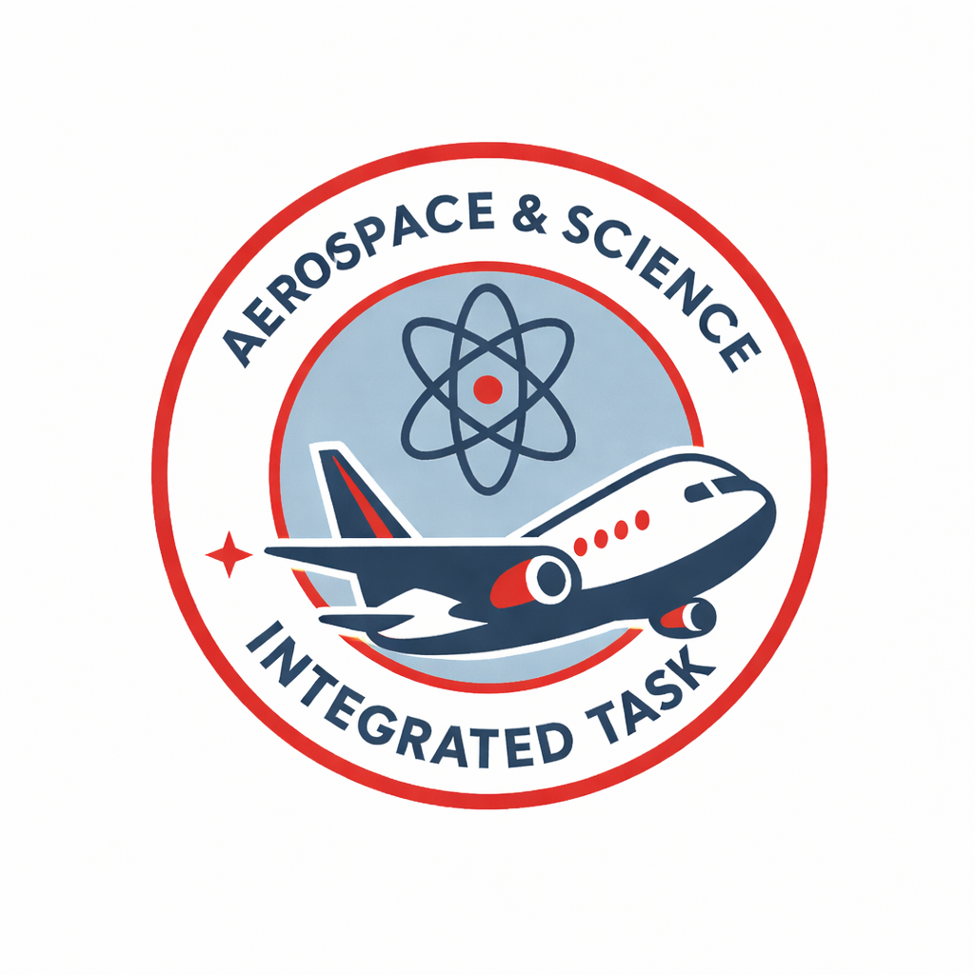  Students test a range of materials to determine which would make the most appropriate heat shield for an aircraft.  Experimental Investigation  Group work  Individual response  Written response (600-800 words)  Feedback to students: individual Values of Inquiry (VOI) written feedback  AI Statement: In this assignment, AI may be used to generate aspects of the task:  Students:  - may use Writer’s Toolbox (WTB) to draft written components and obtain feedback on their writing  - may use Corella (EQ generative AI platform) to obtain feedback on aspects of their assignment  - may use Corella to construct the method and equipment list | Due: Week 9 | After studying about chemical change and conservation of mass, students complete an exam. They examine the relationship between chemistry, technology and engineering.  Examination  2x 60 minutes  Written response, under supervised conditions  Feedback to students: quizzes, diagnostic tests, formative assessment  AI Statement: In this exam, students may not use AI for any aspect of the task | Due: Week 9 | Students describe how the processes of sexual and asexual reproduction enable the survival of the species.  Examination  1x 60 minutes  Written response, under supervised conditions  Feedback to students: quizzes, diagnostic tests, formative assessment  AI Statement: In this exam, students may not use AI for any aspect of the task |  | Due: Week 3-4 | In preparation for the mock UN debate, students create an infographic describing the carbon cycle and its impact on climate change.  Infographic  Visual, written (1x A4 page)  Independent work  Feedback to students: whole class feedback  AI Statement: In this assignment, AI may be used to generate aspects of the task:  Students:  - may use Corella to create their infographic  - may use Corella to research their infographic  - may use Corella to generate a reference list  - may use WTB to draft written components and obtain feedback on their writing |  | Due:  Week 2-3
 |  |  |  |  | Assessment — Coordination & Control |  | Timing | Assessment — Mock UN debate |  | Timing
 |  |  |  |  | Students diagnose a medical case – from a set of provided cases – and describe how technology might assist the patient in the management of their illness.  Research Investigation  Individual response  Written response (500-600 words)  In class essay  Feedback to students: whole class feedback/ incidental teacher feedback during research phase  AI Statement: In this assignment, AI may be used to generate aspects of the task:  Students:  - may use Writer’s Toolbox (WTB) to draft written components and use WTB to obtain feedback on their draft writing  - may use Corella to produce a page of notes to bring into the lesson to assist with the construction of the written task |  | Due: Week 9 | In groups, students are assigned a country. They research the impact of climate change – specifically the carbon cycle – on that country’s population. Students present their ideas to the class in a mock UN-style debate.  Performance (Earth, Space Science)  Spoken  Group work  Responses individually marked  Feedback to students: individual checklist during research and reflection phases  AI Statement: In this assignment, AI may be used to generate aspects of the task:  Students:  - may use Corella to research information to create notes for the mock UN debate  - may use Corella to generate a reference list  - may use Corella to generate feedback  - may use WTB to draft written components and obtain feedback on their writing
Achievement standard | By the end of Year 9 students explain how body systems provide a coordinated response to stimuli. They describe how the processes of sexual and asexual reproduction enable survival of the species. They explain how interactions within and between Earth’s spheres affect the carbon cycle. They analyse energy conservation in simple systems and apply wave and particle models to describe energy transfer. They explain observable chemical processes in terms of changes in atomic structure, atomic rearrangement and mass. Students explain the role of publication and peer review in the development of scientific knowledge and explain the relationship between science, technologies and engineering. They analyse the different ways in which science and society are interconnected.  Students plan and conduct safe, reproducible investigations to test or identify relationships and models. They describe how they have addressed any ethical and intercultural considerations when generating or using primary and secondary data. They select and use equipment to generate and record replicable data with precision. They select and construct appropriate representations to organise, process and summarise data and information. They analyse and connect data and information to identify and explain patterns, trends, relationships and anomalies. They analyse the impact of assumptions and sources of error in methods and evaluate the validity of conclusions and claims. They construct logical arguments based on evidence to support conclusions and evaluate claims. They select and use content, language and text features effectively to achieve their purpose when communicating their ideas, findings and arguments to specific audiences. |  | By the end of Year 9 students explain how body systems provide a coordinated response to stimuli. They describe how the processes of sexual and asexual reproduction enable survival of the species. They explain how interactions within and between Earth’s spheres affect the carbon cycle. They analyse energy conservation in simple systems and apply wave and particle models to describe energy transfer. They explain observable chemical processes in terms of changes in atomic structure, atomic rearrangement and mass. Students explain the role of publication and peer review in the development of scientific knowledge and explain the relationship between science, technologies and engineering. They analyse the different ways in which science and society are interconnected.  Students plan and conduct safe, reproducible investigations to test or identify relationships and models. They describe how they have addressed any ethical and intercultural considerations when generating or using primary and secondary data. They select and use equipment to generate and record replicable data with precision. They select and construct appropriate representations to organise, process and summarise data and information. They analyse and connect data and information to identify and explain patterns, trends, relationships and anomalies. They analyse the impact of assumptions and sources of error in methods and evaluate the validity of conclusions and claims. They construct logical arguments based on evidence to support conclusions and evaluate claims. They select and use content, language and text features effectively to achieve their purpose when communicating their ideas, findings and arguments to specific audiences. |  | By the end of Year 9 students explain how body systems provide a coordinated response to stimuli. They describe how the processes of sexual and asexual reproduction enable survival of the species. They explain how interactions within and between Earth’s spheres affect the carbon cycle. They analyse energy conservation in simple systems and apply wave and particle models to describe energy transfer. They explain observable chemical processes in terms of changes in atomic structure, atomic rearrangement and mass. Students explain the role of publication and peer review in the development of scientific knowledge and explain the relationship between science, technologies and engineering. They analyse the different ways in which science and society are interconnected.  Students plan and conduct safe, reproducible investigations to test or identify relationships and models. They describe how they have addressed any ethical and intercultural considerations when generating or using primary and secondary data. They select and use equipment to generate and record replicable data with precision. They select and construct appropriate representations to organise, process and summarise data and information. They analyse and connect data and information to identify and explain patterns, trends, relationships and anomalies. They analyse the impact of assumptions and sources of error in methods and evaluate the validity of conclusions and claims. They construct logical arguments based on evidence to support conclusions and evaluate claims. They select and use content, language and text features effectively to achieve their purpose when communicating their ideas, findings and arguments to specific audiences. |  |  | By the end of Year 9 students explain how body systems provide a coordinated response to stimuli. They describe how the processes of sexual and asexual reproduction enable survival of the species. They explain how interactions within and between Earth’s spheres affect the carbon cycle. They analyse energy conservation in simple systems and apply wave and particle models to describe energy transfer. They explain observable chemical processes in terms of changes in atomic structure, atomic rearrangement and mass. Students explain the role of publication and peer review in the development of scientific knowledge and explain the relationship between science, technologies and engineering. They analyse the different ways in which science and society are interconnected.  Students plan and conduct safe, reproducible investigations to test or identify relationships and models. They describe how they have addressed any ethical and intercultural considerations when generating or using primary and secondary data. They select and use equipment to generate and record replicable data with precision. They select and construct appropriate representations to organise, process and summarise data and information. They analyse and connect data and information to identify and explain patterns, trends, relationships and anomalies. They analyse the impact of assumptions and sources of error in methods and evaluate the validity of conclusions and claims. They construct logical arguments based on evidence to support conclusions and evaluate claims. They select and use content, language and text features effectively to achieve their purpose when communicating their ideas, findings and arguments to specific audiences.
Moderation | Year 9 coordinator to email tasks to the Year 9 science team at the end of term 4 of the previous year. This should include task, unit plan, proposed adjusted assessment for SWD. Feedback on task/s to be given to the coordinator by the end of week 1. Calibration meeting to be held by the end of week 2. Meeting to be led by Year 9 science coordinator. No major adjustments to occur during calibration meeting. Year 9 science coordinator to facilitate a draft moderation meeting in about week 8. Students are to be given feedback based on teacher moderation. HOD may include a focus group with Year 9 students on the difficulty of the task/s. Assessment may be utilised for whole school moderation in week 10. |  | Year 9 coordinator to email tasks to the Year 9 science team by the end of term 1. This should include task, unit plan, proposed adjusted assessment for SWD. Feedback on task/s to be given to the coordinator by the end of week 1. Calibration meeting to be held by the end of week 2. Meeting to be led by Year 9 science coordinator. No major adjustments to occur during calibration meeting. Year 9 science coordinator to facilitate a draft moderation meeting in about week 8. Students are to be given feedback based on teacher moderation. HOD may include a focus group with Year 9 students on the difficulty of the task/s. Assessment may be utilised for whole school moderation in week 10. |  | Year 9 coordinator to email tasks to the Year 9 science team by the end of term 2. This should include both tasks, unit plan, proposed adjusted assessment for SWD. Feedback on task/s to be given to the coordinator by the end of week 1. Calibration meeting to be held by the end of week 2. Meeting to be led by Year 9 science coordinator. No major adjustments to occur during calibration meeting. Year 9 science coordinator to facilitate a draft moderation meeting in about week 8. Students are to be given feedback based on teacher moderation. HOD may include a focus group with Year 9 students on the difficulty of the task/s. Assessment may be utilised for whole school moderation in week 10. |  |  | Year 9 coordinator to email tasks to the Year 9 science team by the end of term 3. This should include both tasks, unit plan, proposed adjusted assessment for SWD. Feedback on task/s to be given to the coordinator by the end of week 1. Calibration meeting to be held by the end of week 2. Meeting to be led by Year 9 science coordinator. No major adjustments to occur during calibration meeting. Year 9 science coordinator to facilitate a draft moderation meeting in about week 8. Students are to be given feedback based on teacher moderation. HOD may include a focus group with Year 9 students on the difficulty of the task/s. Assessment may be utilised for whole school moderation in week 10.

Content descriptions | Units |  |  |  | Content descriptions | Units |  |  |  | Content descriptions | Units
Science understanding | 1 | 2 | 3 | 4 | Science as a human endeavour | 1 | 2 | 3 | 4 | Science inquiry | 1 | 2 | 3 | 4
Biological sciences  compare the role of body systems in regulating and coordinating the body’s response to a stimulus, and describe the operation of a negative feedback mechanism AC9S9U01 |  |  | R |  | Nature and development of science  explain how scientific knowledge is validated and refined, including the role of publication and peer review AC9S9H01 |  |  |  | R | Questioning and predicting  develop investigable questions, reasoned predictions and hypotheses to test relationships and develop explanatory models AC9S9I01 | R
describe the form and function of reproductive cells and organs in animals and plants, and analyse how the processes of sexual and asexual reproduction enable survival of the species AC9S9U02 |  |  | R |  | investigate how advances in technologies enable advances in science, and how science has contributed to developments in technologies and engineering AC9S9H02 |  | R | R |  | Planning and conducting  plan and conduct valid, reproducible investigations to answer questions and test hypotheses, including identifying and controlling for possible sources of error and, as appropriate, developing and following risk assessments, considering ethical issues, and addressing key considerations regarding heritage sites and artefacts on Country/Place AC9S9I02 | R
Earth and space sciences  represent the carbon cycle and examine how key processes including combustion, photosynthesis and respiration rely on interactions between Earth’s spheres (the geosphere, biosphere, hydrosphere and atmosphere) AC9S9U03 |  |  |  | R | Use and influence of science  analyse the key factors that contribute to science knowledge and practices being adopted more broadly by society AC9S9H03 |  | R | R | R | select and use equipment to generate and record data with precision to obtain useful sample sizes and replicable data, using digital tools as appropriate AC9S9I03 | R
Physical sciences  use wave and particle models to describe energy transfer through different mediums and examine the usefulness of each model for explaining phenomena AC9S9U04 | R |  |  |  | examine how the values and needs of society influence the focus of scientific research AC9S9H04 |  |  | R | R | Processing, modelling and analysing  select and construct appropriate representations, including tables, graphs, descriptive statistics, models and mathematical relationships, to organise and process data and information AC9S9I04 | R |  |  | R
apply the law of conservation of energy to analyse system efficiency in terms of energy inputs, outputs, transfers and transformations AC9S9U05 | R |  |  |  |  |  |  |  |  | analyse and connect a variety of data and information to identify and explain patterns, trends, relationships and anomalies AC9S9I05 | R
Chemical sciences  explain how the model of the atom changed following the discovery of electrons, protons and neutrons and describe how natural radioactive decay results in stable atoms AC9S9U06 |  | R |  |  |  |  |  |  |  | Evaluating  assess the validity and reproducibility of methods and evaluate the validity of conclusions and claims, including by identifying assumptions, conflicting evidence and areas of uncertainty AC9S9I06 | R
model the rearrangement of atoms in chemical reactions using a range of representations, including word and simple balanced chemical equations, and use these to demonstrate the law of conservation of mass AC9S9U07 |  | R |  |  |  |  |  |  |  | construct arguments based on analysis of a variety of evidence to support conclusions or evaluate claims, and consider any ethical issues and cultural protocols associated with accessing, using or citing secondary data or information AC9S9I07 | R |  | R | R
 |  |  |  |  |  |  |  |  |  | Communicating  write and create texts to communicate ideas, findings and arguments effectively for identified purposes and audiences, including selection of appropriate content, language and text features, using digital tools as appropriate AC9S9I08 |  |  | R | R
Note: Adjust the table to reflect the number of units you will offer. Check or uncheck the columns as appropriate for each unit.
General capabilities | Units |  |  |  |  | Cross-curriculum priorities | Units
 | 1 | 2 | 3 | 4 |  |  | 1 | 2 | 3 | 4
Critical and creative thinking | R |  | R | R |  | Aboriginal and Torres Strait Islander histories and cultures |  |  |  | R
Digital literacy |  |  |  | R |  | Asia and Australia’s engagement with Asia |  |  |  | R
Ethical understanding |  | R | R | R |  | Sustainability |  |  |  | R
Intercultural understanding |  |  |  | R
Literacy | R | R | R | R
Numeracy | R
Personal and social capability | R | R | R | R
 © State of Queensland (QCAA) 2023
Licence: https://creativecommons.org/licenses/by/4.0 | Copyright notice: www.qcaa.qld.edu.au/copyright — lists the full terms and conditions, which specify certain exceptions to the licence. | Attribution (include the link): © State of Queensland (QCAA) 2023 www.qcaa.qld.edu.au/copyright.
Unless otherwise indicated material from the Australian Curriculum is © ACARA 2010–present, licensed under CC BY 4.0. For the latest information and additional terms of use, please check the Australian Curriculum website and its copyright notice.

