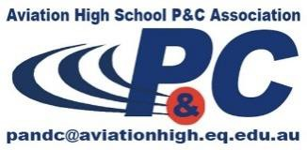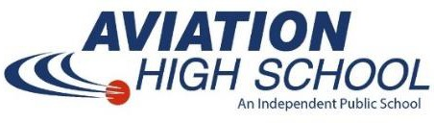

Aviation High School
Parent and Citizens Association (P&C)

All parents and friends are invited to join the P&C Association. Meetings are held in the Canteen at 6.15pm every second Monday of the month during school terms, except where it falls on a public holiday.

2024 Meeting Dates

Monday Monday Monday Monday Monday Monday Monday Monday
12 February
11 March - AGM
13 May
10 June
8 July
12 August
14 October
11 November

Any questions regarding the P&C Association can be emailed to the President at pandc@aviationhigh.eq.edu.au

